**GRID/GAR Receipt Interface**

**Request Queue:** GRID.GXWI1P01.REQUESTQ

**Reply Queue:** GRID.GXWI1P01.REPLYTOQ

**Input Copybook:**



**Output Copybooks:**

 

**Process:**

The Input copybook contains an obsolete area prefixed with HNET. This is old Hertz Net code and I do not think it is populated currently. The Hertz.com programmers should be able to tell you how/if this is being populated. The main part in use is the GXWI-PASS-REC. Some fields must be populated on the initial call into GRID/GAR. The GXWI-RQST-CD should be set to L2 for Grid to provide the list of qualifying rentals and D2 once a rental from the list has been selected for viewing. I will discuss the email option below. Do not use the plain L or D options.

That copybook contains a variable layout area that contains the detail data to be sent. The GXWI-DATA-REC field on either the list or detail request will be populated with the GXWI-WEB-INPUT copybook data. The length of that data will need to be in the GXWI-DATA-LEN variable. On input requests that length is 200.

On the initial call, the following fields should be populated:

GXWI-CC-NUMBER and GXWI-CC-TYPE-CODE (type code from drop down list on web)

**Or** GXWI-DL-NBR and GXWI-DL-ISS-STATE/GXWI-DL-ISS-CTRY (use ISO state and country codes)

GXWI-CKOT-BEG-DT (YYYYMMDD checkout date range start -default to 6 months prior to current date)

GXWI-CKOT-END-DT (YYYYMMDD checkout date range end – default should be current date)

GXWI-LANG (Optional will default to billing language)

GXWI-LNAME (Last Name)

The response will include the HNET-GBCM-RECORD (which includes the GXWI-PASS-REC) and in the variable area will first be the 200 byte GXWI-WEB-INPUT followed by the List Response Copybook.

The list response copybook contains the information needed to create a list of transactions for the user to select. The number of matches is in the GXWI-NBR-HITS2 field followed by a data block for each record.

Once the list is displayed, if the user selects a rental for viewing, the GXWI-XACT-NBR and GXWI-XACT-VERS-NBR of the record selected will need to be moved to the GXWI-GRID-XACT and GXWI-GRID-VERS in the GXWI-WEB-INPUT copybook and then the D2 request code selected and another call made.

The response for that call will include the HNET-GBCM-RECORD (which includes the GXWI-PASS-REC) and in the variable area will first be the 200 byte GXWI-WEB-INPUT followed by the HTML Response copybook from above. The FX20-LINE-CNT will have the number of HTML lines which are in the FX20-HTML table. In the current environment, that HTML is wrapped with other HTML to create a new window with the receipt displayed. Below is a sample of the HTML returned:



**Email Option**

In Europe, VAT reclaim is a very big deal for business customers. They often request copies of receipts for this purpose, however the HTML invoice is not compliant with most countries’ legal requirements. Rather than having customers call in for missing receipts, there is a web option that allows the customers to request an emailed copy of the receipt in PDF format. On the List Response, invoices that meet the requirements for VAT Reclaim will have the GXWI-VATABLE-INVC variable set to Y. If the user has one of these on the list and selects the email option, they will be prompted to enter their email address (see images below). That value is moved to the GXWI-EMAIL-ADDR (up to 40 chars). The same fields must also be populated as the Detail request, however with E in the GXWI-RQST-CD. The response data should be the same as what was sent in.

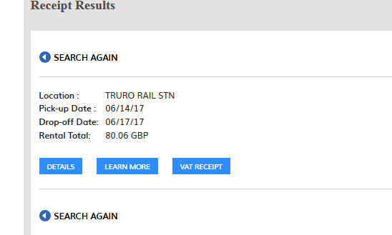 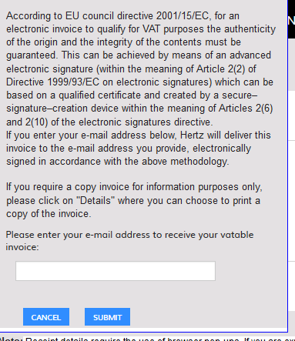

**Error Handling**

The field GXWI-ERR-CD should be blank or all zeros with a good call. If it is not, then an error message should be in the GXWI-ERR-MSG field.